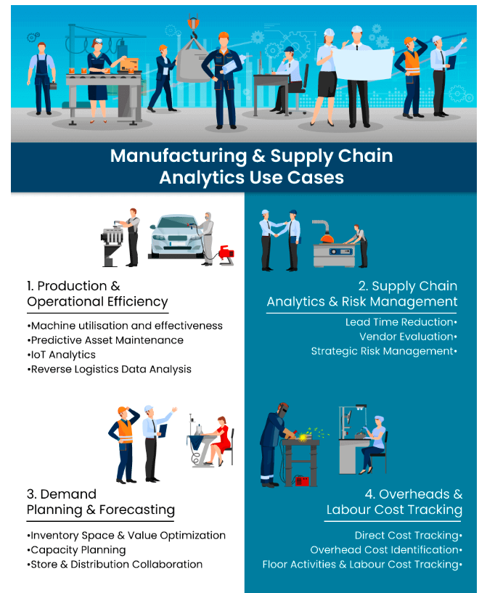

Diagnostic Analytics:

### 1. Production Analytics for Operational Efficiency

There are a series of processes going on in parallel and it generates a huge volume of data ranging from machine run-time to no. of units produced. When all this information is decoupled, analyzed, and resynched together in a system, the results can be very powerful.

Machinery and systems are constantly operating for long stretches under heavy loads and any fault can significantly impact on your production. As a reactive approach is not sustainable, by using predictive analytics systems, factory supervisors can predict failures in advance and avoid downtime. A practice that is catching trend is self-correcting machines that warn once such a threshold is achieved.

Machine utilization and effectiveness data can lead to some crucial insights like

* The average run time for each machine and the reasons for any deviations from the schedule (human error, raw-material scarcity, technical issues, etc)
* Predictive Asset Maintenance- for which IoT data from sensors can be pulled and analyzed to understand the pain areas and help in improving machine efficiency
* Monitor and predict the quality of goods based on machine sensors, quality control charts, and more.

These can show benefit by reducing the maintenance costs, improving machine efficiency, reliability and more. It is estimated that [Predictive maintenance](https://www.polestarllp.com/blog/predictive-analytics-in-manufacturing-optimize-business-operations-and-maintenance) has the potential to reduce maintenance costs by 19%.

In addition to the manufacturing production line, the use of analytics is often limited to warehouse optimization and forward logistics. However, while performing [Reverse Logistics Analytics](https://www.polestarllp.com/blog/reverse-logistics-analytics) on numerous occasions organizations have dug up some hidden insights into sunk costs and inefficiencies cropping up from certain activities.

Analysis of returned items provides insights related to which stage of the production process is generating the maximum volume of faulty pieces or end products. It leads to avoiding loss emanating due to customers' dissatisfaction as well as the sunk cost associated with manufacturing them. Further, it also adds to optimizing the existing processes, updating the vendor scorecard and ratings.

Advanced data analytics in manufacturing maximizes operational efficiency through three key applications: Predictive Asset Maintenance, Yield/throughput analysis and Supply chain optimization with advanced modelling.

### 2. Warehouse layout optimization

Warehouse layout is about leveraging technology to gather real-time data, analyze it to gain valuable insights, and optimize warehouse operations.

Automated systems like robots, conveyors, and automated guided vehicles (AGVs) constantly collect data on inventory levels, location, movement, and performance metrics. This data is then analyzed using advanced analytics tools to identify trends, bottlenecks, and areas for improvement. For example, analyzing data on picking times and travel distances can optimize picking routes and improve efficiency.

<https://www.youtube.com/watch?v=8huwyHfHR0g>

E-commerce retailers like Walmart and Amazon are heavily investing in warehouse automation to handle the increasing volume of online orders. Manufacturers are using supply chain analytics and automation to optimize their warehousing operations and streamline the supply chain for their products.

### 3. Carbon Footprint tracking and reduction

Carbon footprint tracking and reduction involves measuring and minimizing greenhouse gas emissions across a company's entire supply chain. It works by establishing a baseline of emissions, using data on energy consumption, transportation, manufacturing, and waste management. Advanced analytics tools process this data to calculate the carbon footprint and identify areas for improvement.

Businesses can use data analytics in supply chain to set and track emissions reduction targets, optimize operations, inform supplier selection, and enhance sustainability reporting. It can be applied to transportation route optimization, energy source selection, product redesign, and supplier engagement.

Results often include reduced operational costs, improved brand image, easier regulatory compliance, and contribution to climate change mitigation. Benefits of carbon footprint tracking go beyond environmental advantages: they can help businesses save costs, offer a competitive advantage in environmentally conscious markets, and access to sustainability-linked opportunities.

However, the extent of these benefits depends on the comprehensiveness of implementation and the company's commitment to acting on the insights gained. While initial costs can be high, many businesses find long-term value in this investment for efficiency, risk management, and reputation.

### 4. Quality control analytics using statistical process control

Quality control analytics using statistical process control (SPC) in supply chain analytics is a data-driven approach to monitoring and improving product quality throughout the manufacturing process. It applies statistical methods to identify, analyze, and reduce variations in production, ensuring consistent quality and minimizing defects.

SPC works by collecting data on various quality parameters during production and analyzing it using statistical tools like control charts and process capability analysis. This helps determine if processes are stable and predictable or if they require intervention. The system continuously monitors production, enabling early detection of issues and facilitating root-cause analysis when problems occur.

### 5. Inventory analytics for smarter stock management

With ever-growing SKUs, a limited shelf space, massive competitions, and thin margins manufacturers are always faced with pressure. This means they must ensure they have the right inventory at multiple levels, from warehouses to the retail shelves. We’ve previously spoken about how sharing data can create more value synergy – this applies to inventory too as tracking products across value chain can lead to a potential gain of ~ [$40 billion](https://www3.weforum.org/docs/WEF_Share_to_Gain_Report.pdf).

Additionally, it can help create true end-to-end visibility and bring more transparency. Depending on the number of companies participating you can create new inventory models upon which analytics can be done easily.

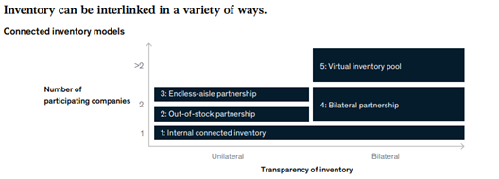

A few types of diagnostic [inventory analytics](https://www.polestarllp.com/blog/inventory-analytics-best-practices-for-smart-decisions-making) techniques in manufacturing include:

* ABC Analysis – inventory is classified based on categories based on consumption value and contribution to profit.
* HML Analysis – inventory is classified based on cost.
* VED Analysis – inventory is classified based on user perception and experience.
* SDE Analysis - classified based on inventory availability and lead time.
* [Inventory Aging analysis](https://www.polestarllp.com/blog/inventory-analytics-best-practices-for-smart-decisions-making) – classified based on the age of inventory

Additionally, manufacturers can leverage predictive analytics use cases like Collaborative Filtering, Causal Inference, Scenario Planning, Neural networks, multi-variate regression models, demand shaping techniques, exponential smoothening for short-term forecasting, etc., to find inferences and forecast data for the future.

Manufacturers must deal with several vendors and distribution partners to procure or distribute different parts or finished goods. It is very important to keep a check on the associated costs and the profitability figures. Having a cost analysis solution that integrates all the information on a single platform and allows you to get actionable insights, can really bring efficiencies across these activities.

Predictive Analytics:

### 1. Predictive maintenance for manufacturing equipment

Predictive maintenance is a game-changer for supply chains, using data to anticipate equipment failures before they occur. Imagine sensors constantly monitoring machinery like forklifts, conveyor belts, and automated storage systems. This data is analyzed using algorithms and machine learning to identify patterns and predict potential breakdowns. Instead of waiting for a breakdown, companies can schedule maintenance during off-peak periods, minimizing disruption to operations.

According to [McKinsey Global Institute](https://www.mckinsey.com/capabilities/operations/our-insights/manufacturing-analytics-unleashes-productivity-and-profitability), “Predictive maintenance typically reduces machine downtime by 30 to 50 percent and increases machine life by 20 to 40 percent.” This proactive approach not only prevents costly repairs and unscheduled downtime but also optimizes maintenance efforts by focusing on components with the highest risk of failure. Furthermore, predictive maintenance allows for more accurate forecasting of spare parts needs, minimizing stockouts and reducing inventory costs.

### 2. Inventory optimization through predictive analytics

Inventory optimization through predictive analytics is a data-driven approach to managing stock levels in supply chain management. This method uses advanced analytics techniques to forecast demand and determine optimal inventory levels, reorder points, and order quantities.

The process involves collecting historical sales data, inventory levels, and other relevant information, then applying statistical methods and machine learning algorithms to identify patterns and predict future demand. These predictions are then used to create mathematical models that optimize inventory across the supply chain.

Ultimately, inventory optimization through predictive analytics is one of those supply chain analytics examples that enable companies to achieve more efficient and cost-effective processes.

3. Production Analytics for Operational Efficiency

There are a series of processes going on in parallel and it generates a huge volume of data ranging from machine run-time to no. of units produced. When all this information is decoupled, analyzed, and resynched together in a system, the results can be very powerful.

Machinery and systems are constantly operating for long stretches under heavy loads and any fault can significantly impact on your production. As a reactive approach is not sustainable, by using predictive analytics systems, factory supervisors can predict failures in advance and avoid downtime. A practice that is catching trend is self-correcting machines that warn once such a threshold is achieved.

Machine utilization and effectiveness data can lead to some crucial insights like

The average run time for each machine and the reasons for any deviations from the schedule (human error, raw-material scarcity, technical issues, etc.)

Predictive Asset Maintenance- for which IoT data from sensors can be pulled and analyzed to understand the pain areas and help in improving machine efficiency

Monitor and predict the quality of goods based on machine sensors, quality control charts, and more.

These can show benefit by reducing the maintenance costs, improving machine efficiency, reliability and more. It is estimated that [Predictive maintenance](https://www.polestarllp.com/blog/predictive-analytics-in-manufacturing-optimize-business-operations-and-maintenance) has the potential to reduce maintenance costs by 19%.

In addition to the manufacturing production line, the use of analytics is often limited to warehouse optimization and forward logistics. However, while performing [Reverse Logistics Analytics](https://www.polestarllp.com/blog/reverse-logistics-analytics) on numerous occasions organizations have dug up some hidden insights into sunk costs and inefficiencies cropping up from certain activities.

Analysis of returned items provides insights related to which stage of the production process is generating the maximum volume of faulty pieces or end products. It leads to avoiding loss emanating due to customers' dissatisfaction as well as the sunk cost associated with manufacturing them. Further, it also adds to optimizing the existing processes, updating the vendor scorecard and ratings.

Advanced data analytics in manufacturing maximizes operational efficiency through three key applications: Predictive Asset Maintenance, Yield/throughput analysis and Supply chain optimization with advanced modelling.

